## Interfacing raspi with Arduino using i2c interface

(Arduino acting as slave to raspi)

First of all in order to establish the interface we need to download packages the packages are python-smbus and i2c-tools

Commands:

1. sudo apt-get install -y python-smbus
2. sudo apt-get install -y i2c-tools

And then we need to enable the i2c interface options in the interfacing options of raspi.

To do this we need to type the command

**sudo raspi-config**

**And then we need to follow the below steps**

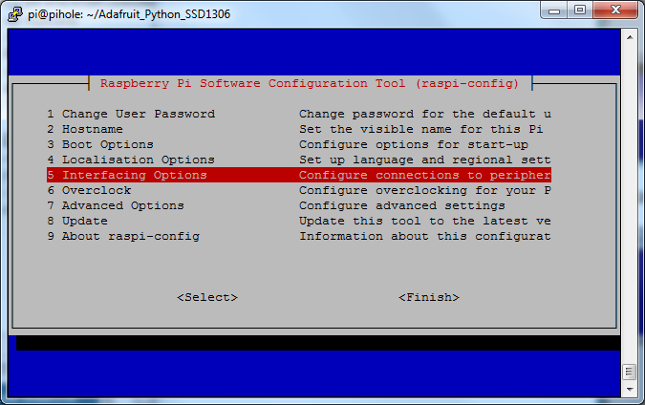

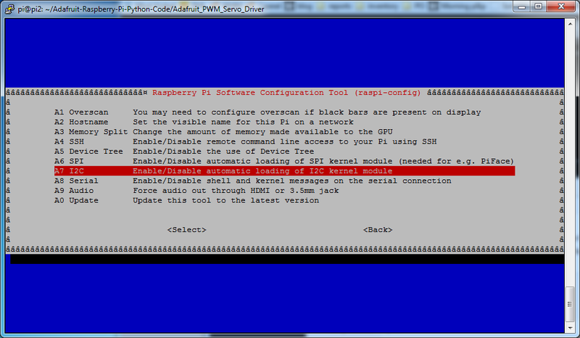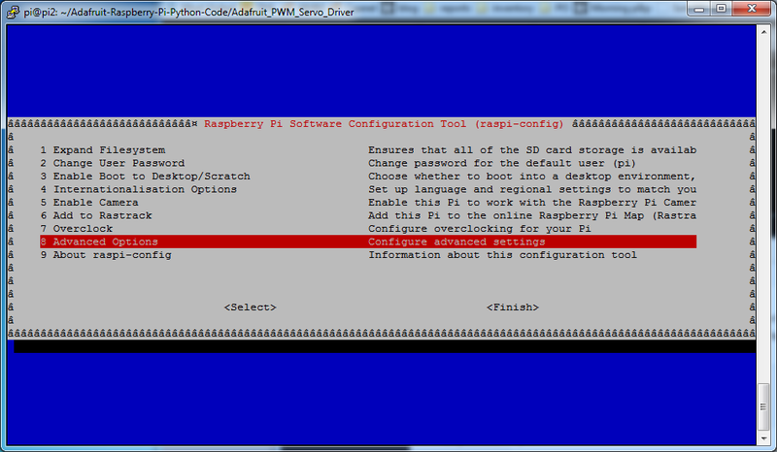

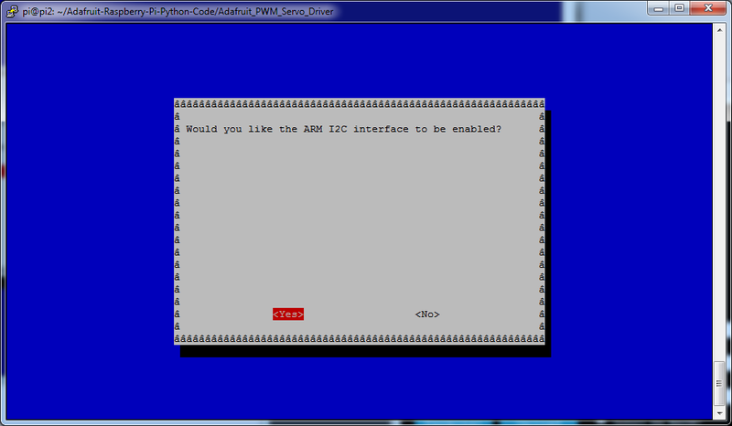

And then the next step is to enable the bcm that is the chip configurations of i2c to run at the time of boot itself for this we need to add the below commands in order to establish the above communication.

Type the command

1. sudo nano /etc/modules

and then add the below two lines to the editor window

1. i2c-bcm2708
2. i2c-dev

then save the file.

If we are using raspberry pi of model 3.18 or higher we need to add some more lines to other editor window in order to complete the interfacing

Type the command

**sudo nano /boot/config.txt**

**and add the below two lines to the window**

**dtparam=i2c1=on  
dtparam=i2c_arm=on**

**once this is done we need to reboot the device inorder to complete the interfacing**

***Establishing connection and compiling the codes***

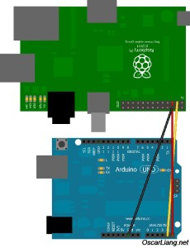

RPI               Arduino (Uno/Duemillanove)

--------------------------------------------

GPIO 0 (SDA) <--> Pin 4 (SDA)

GPIO 1 (SCL) <--> Pin 5 (SCL)

Ground       <--> Ground

**To check whether Arduino is connected or not and to identify whether address is established or not we need to type the command given below**

**Sudo i2cdetect -y 1**

**And then the below list should appear for raspberry pi 3**

pi@raspberrypi ~ $ i2cdetect -y 1

     0  1  2  3  4  5  6  7  8  9  a  b  c  d  e  f

00: -- 04 -- -- -- -- -- -- -- -- -- -- --

10: -- -- -- -- -- -- -- -- -- -- -- -- -- -- -- --

20: -- -- -- -- -- -- -- -- -- -- -- -- -- -- -- --

30: -- -- -- -- -- -- -- -- -- -- -- -- -- -- -- --

40: -- -- -- -- -- -- -- -- -- -- -- -- -- -- -- --

50: -- -- -- -- -- -- -- -- -- -- -- -- -- -- -- --

60: -- -- -- -- -- -- -- -- -- -- -- -- -- -- -- --

70: -- -- -- -- -- -- -- --

**After this you need to upload the code in the Arduino with some functions included in it and also you need to enter code in raspberry pi.**

**The codes are given below**

**Code for raspi:**

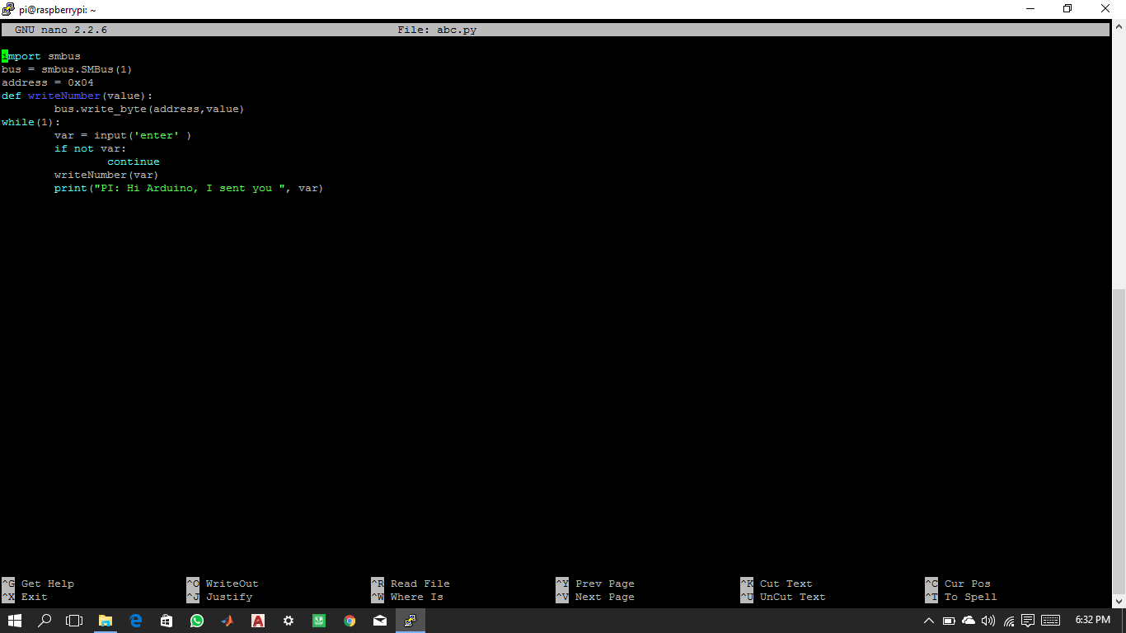

Smbus stands for system management bus it does the work of putting the value on to the Arduino from the raspi

Bus=smbus.SMBus(1)

1 is the code for the raspberry pi 3 it activates the smbus

Default address is 0x04

Code for Arduino:

#include <Wire.h>  
#define SLAVE_ADDRESS 0x04 this command is to define the address of arduino  
#include<Servo.h>  
int j=0,i=0,x=90;  
Servo servo;  
void setup()  
{  
    servo.attach(2);  
    pinMode(13, OUTPUT);  
    Serial.begin(9600);  
    Wire.begin(SLAVE_ADDRESS); this command is to activate the wire of the address   
    Wire.onReceive(receiveData); this command is to receive the data   
}  
void loop()  
{  
 delay(100);  
}  
void receiveData(int byteCount)  
{  
    while(Wire.available())   
      {  
       x= Wire.read();  
       Serial.println(j);  
         for(i=0;i<=x;i++)  
            {  
             servo.write(i);  
             delay(1000);  
            }  
//         for(i=x;i=0;i--)  
//            {  
//              servo.write(i);  
//              delay(1000);  
//            }  
       }  
}